# **📐 System Architecture Document: EDU-GEN AI Assistant**

## **📌 Overview**

The **EDU-GEN AI Assistant** is a voice-based, multilingual AI chatbot system that enables real-time communication with users. It integrates various AI tools and modules including LangGraph (for agent orchestration), LLM APIs (Groq, OpenAI), STT/VAD (Speech Recognition), and TTS (ElevenLabs).

This architecture ensures modularity, scalability, and responsiveness suitable for multi-user educational and conversational use cases.

**🧱 High-Level Architecture**

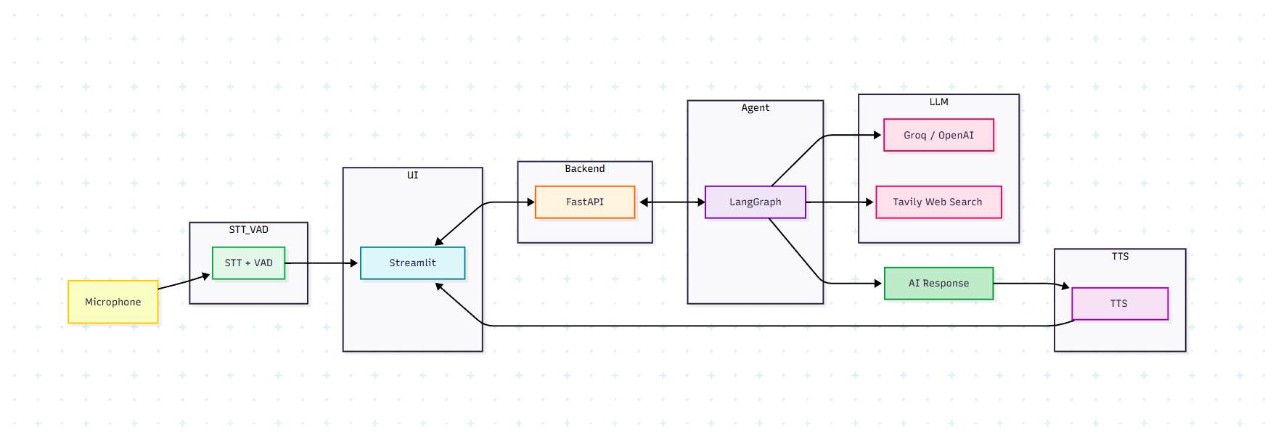

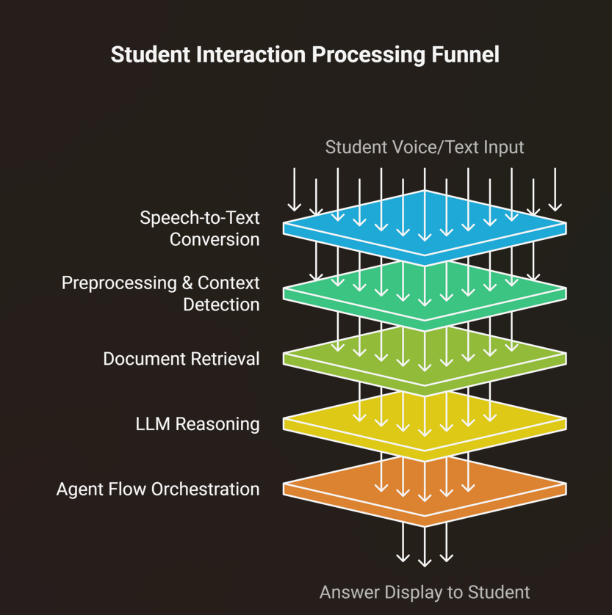

## **🛠️ Core Components**

### **1. Frontend (``)**

* Built using **Streamlit**
* UI allows:
  + Text or voice input
  + Language and model selection
  + TTS output
  + Quiz generation & download
* Maintains session state per user for chat history, language, and last query.

### **2. Voice Agent (``)**

* CLI-based voice interface
* Uses speech_recognition for STT and ambient noise filtering
* Sends queries to FastAPI backend
* Uses ElevenLabs TTS for spoken response

### **3. Backend API (``)**

* Built with **FastAPI**
* Exposes /chat and /generate_quiz endpoints
* Validates input using Pydantic models
* Adds language-specific system prompts dynamically
* Generates quizzes and PDFs using ReportLab

### **4. AI Agent Core (``)**

* Manages LangGraph REACT agent
* Dynamically chooses between OpenAI and Groq LLMs
* Integrates **Tavily Search Tool** if allow_search=True
* Handles:
  + Memory state (via messages array)
  + Tool selection
  + Response parsing from AIMessage

## **🧠 Data Flow Diagram (Voice Path)**

1. **Voice Input (Microphone)**
2. ➡️ Transcribed using speech_recognition → Text
3. ➡️ Sent to /chat endpoint with model config
4. ➡️ LangGraph agent handles logic & memory
5. ➡️ AI response parsed → returned to frontend
6. ➡️ Converted to speech using ElevenLabs
7. 🎧 Played back to user

## **🌐 Multi-User Handling**

* Streamlit's session_state keeps track of:
  + Chat history
  + Selected language, voice, and model
  + TTS audio path
* No persistent storage or DB is used; state is per session

## **📄 System Design Deliverables**

Include the following in your GitHub repo:

* system_design.pdf or system_design.png:
  + A visual diagram (similar to the ASCII above)
  + Explain component interaction
  + Highlight voice & text routes
* This Markdown/README file for detailed explanation

## **✅ Key Technologies**

* **LangGraph + LangChain**: REACT agent for stateful reasoning
* **Groq / OpenAI GPT**: LLM inference
* **Tavily**: External search tool integration
* **ElevenLabs**: Voice synthesis (TTS)
* **SpeechRecognition (Google)**: Voice transcription
* **FastAPI**: REST API service
* **Streamlit**: Web frontend
* **ReportLab**: Quiz PDF generation

## **🏁 Conclusion**

This architecture is modular, flexible, and voice-first — making it ideal for educational chatbots, multilingual tutors, or assistive agents.

Let me know if you want me to generate a **visual diagram (PNG)** from this architecture!